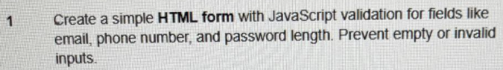
<!DOCTYPE html>
<html>
<body>

<h3>Registration Form</h3>

<form onsubmit="return validate()">
Email: <input type="text" id="email"><br><br>
Phone: <input type="text" id="phone"><br><br>

Password: <input type="password" id="pass" onkeyup="checkPass()"><br>
<small id="msg" style="color:blue;"></small><br><br>

<button type="submit">Submit</button>
</form>

<script>
function validate() {
let e = document.getElementById("email").value;
let p = document.getElementById("phone").value;
let pass = document.getElementById("pass").value;

if (e == "" || p == "" || pass == "") {
alert("Fields cannot be empty");
return false;
}
if (!e.includes("@") || !e.includes(".")) {
alert("Invalid email");
return false;
}
if (p.length != 10 || isNaN(p)) {
alert("Phone must be 10 digits");
return false;
}
if (pass.length < 8 || !/\d/.test(pass) || !/[!@#$%]/.test(pass)) {
alert("Weak password");
return false;
}

alert("Form Submitted!");
return true;
}

function checkPass() {
let pass = document.getElementById("pass").value;
let msg = "Strong Password";

if (pass.length < 8) msg = "Min 8 characters";
else if (!/\d/.test(pass)) msg = "Add a number";
else if (!/[!@#$%]/.test(pass)) msg = "Add a special char";

document.getElementById("msg").innerHTML = msg;
}
</script>

</body>
</html>

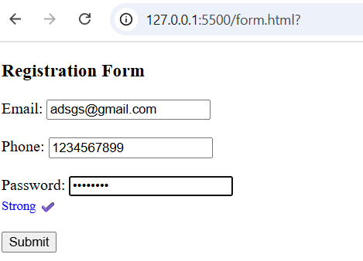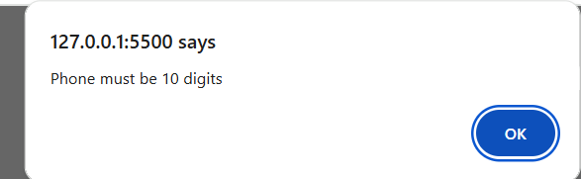

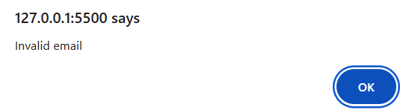

<!DOCTYPE html>
<html>
<body>

<h3>Login</h3>

<form onsubmit="return login()">
Email: <input type="text" id="email"><br><br>
Password: <input type="password" id="pass"><br><br>
<button type="submit">Login</button>
</form>

<br>
<button onclick="logout()">Logout</button>

<p id="status"></p>

<script>
// Set cookie on login
function login() {
let e = document.getElementById("email").value;
let p = document.getElementById("pass").value;

if(e == "" || p == "") {
alert("Fields cannot be empty");
return false;
}

// Simple mock credentials
if(e == "user@test.com" && p == "12345") {
document.cookie = "session=active; path=/";
document.getElementById("status").innerHTML = "✅ Logged in!";
} else {
alert("Invalid login");
return false;
}
return false; // prevent page refresh
}

// Clear cookie on logout
function logout() {
document.cookie = "session=; max-age=0; path=/";
document.getElementById("status").innerHTML = "🚪 Logged out!";
}
</script>

</body>
</html>

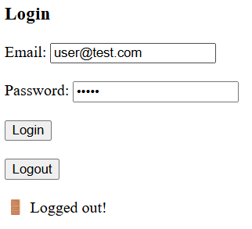

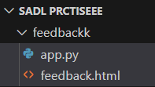
feedback.html
<!DOCTYPE html>
<html>
<body>

<h3>Feedback Form</h3>

<form method="POST" action="/submit" onsubmit="return check();">
Name: <input id="name" name="name"><br><br>
Feedback: <textarea id="fb" name="fb"></textarea><br><br>
<button type="submit">Send</button>
</form>

<script>
function check(){
if(name.value.trim()=="" || fb.value.trim()==""){
alert("Fields cannot be empty");
return false;
}
if(name.value.includes("<script") || fb.value.includes("<script")){
alert("Script not allowed");
return false;
}
return true; // allow submit
}
</script>

</body>
</html>

app.py
from flask import Flask, request
app = Flask(__name__)

@app.route("/") # ✅ This will display the form
def home():
return open("feedback.html").read() # ✅ Loads your HTML file

@app.route("/submit", methods=["POST"])
def submit():
name = request.form["name"].strip()
fb = request.form["fb"].strip()

if name == "" or fb == "":
return "Error: Empty fields"
if "<script" in name.lower() or "<script" in fb.lower():
return "Error: Script tag not allowed"

return "Feedback Received: " + name + " - " + fb
app.run()
Python
caesar.py
def caesar_cipher(text, shift, mode='encrypt'):
result = ''
if mode == 'decrypt':
shift = -shift

for char in text:
if char.isalpha():
base = ord('A') if char.isupper() else ord('a')
result += chr((ord(char) - base + shift) % 26 + base)
else:
result += char
return result

# Example usage
message = "Hello World!"
shift = 4

encrypted = caesar_cipher(message, shift, 'encrypt')
decrypted = caesar_cipher(encrypted, shift, 'decrypt')

print("Encrypted:", encrypted)
print("Decrypted:", decrypted)

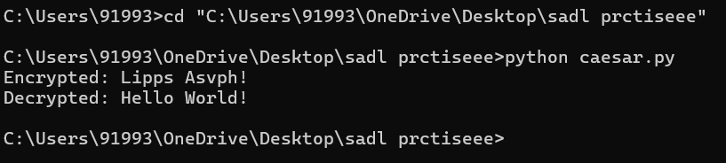
<!doctype html>
<html>
<head><meta charset="utf-8"><title>SQLi Demo (No DB)</title></head>
<body>
<h3>Stored: admin / admin123</h3>

<h4>Vulnerable (simulated)</h4>
User: <input id="v_u"><br>
Pass: <input id="v_p"><br>
<button onclick="vuln()">Run</button>
<pre id="v_out"></pre>

<h4>Secure (simulated)</h4>
User: <input id="s_u"><br>
Pass: <input id="s_p"><br>
<button onclick="sec()">Run</button>
<pre id="s_out"></pre>

<script>
const storedUser = "admin";
const storedPass = "admin123";

function vuln(){
const u = document.getElementById('v_u').value;
const p = document.getElementById('v_p').value;
const fake = `SELECT * FROM users WHERE username = '${u}' AND password = '${p}'`;
let out = "Fake SQL: " + fake + "\n";
if (fake.includes("' OR '1'='1")) out += "✅ Login SUCCESS (VULNERABLE - injection worked!)";
else if (u===storedUser && p===storedPass) out += "✅ Login SUCCESS (correct creds)";
else out += "❌ Login FAILED";
document.getElementById('v_out').textContent = out;
}

function sec(){
const u = document.getElementById('s_u').value;
const p = document.getElementById('s_p').value;
let out = "Secure check: direct value comparison\n";
if (u===storedUser && p===storedPass) out += "✅ Login SUCCESS (SECURE)";
else out += "❌ Login FAILED (SECURE)";
document.getElementById('s_out').textContent = out;
}
</script>
</body>
</html>

